**FLORITO INTERNSHIP**

**Topics covered:**

1.Introduction to full stack web development

2.Introduction to HTML and CSS

3.HTML tags

4.Login page

5.Responsive web page using HTML and CSS

6.Database connectivity using PHP and DBMS

**Key words and points**:

HTML tags:

1.<HTML>: defines the root of the document.

2.<title>: title of the document.

3.<h1>: heading.

4.<p>: paragraph.

5.<body>: defines body of the document.

CSS basics:

CSS (Cascading Style Sheets) is the code that styles web content.

CSS: all about boxes

padding: the space around the content. In the example below, it is the space around the paragraph text.

border: the solid line that is just outside the padding.

margin: the space around the outside of the border.

Xampp:

It’s a completely free, easy to install Apache distribution containing MariaDB, PHP and Perl.

Database Connectivity:

Using PHP:

In PHP, we can connect to the database using XAMPP web server by using the following path.

“localhost/phpmyadmin”

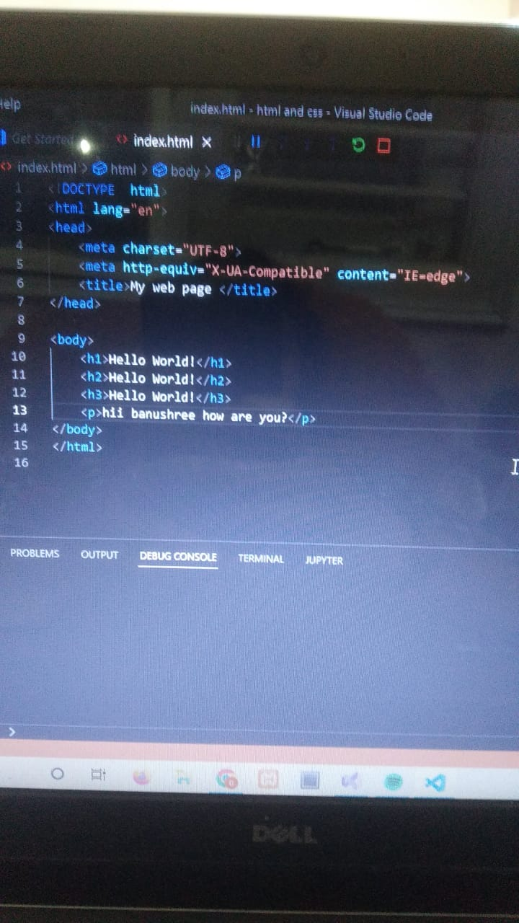

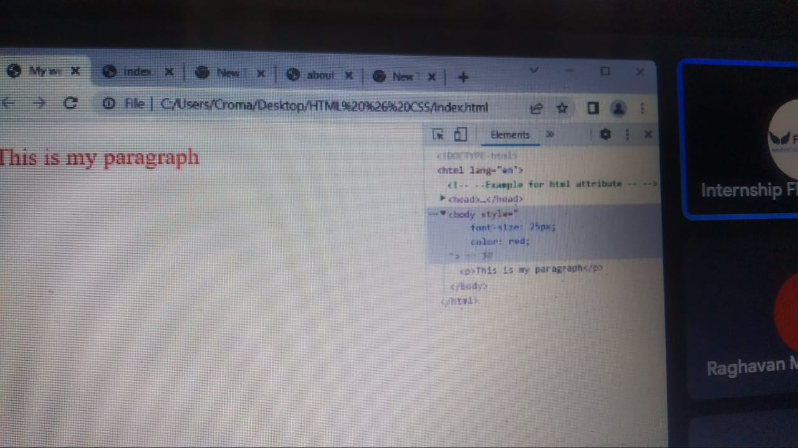

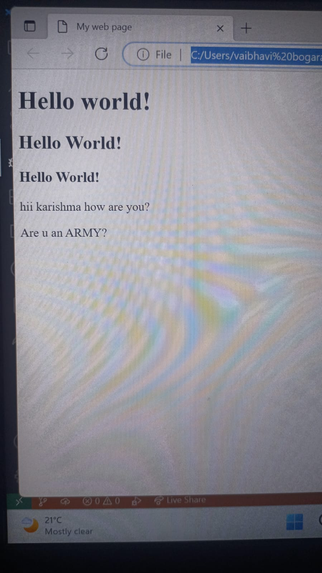

Thank you

PALLAVI K G

JIT 5th sem